STRICTLY PRIVATE AND CONFIDENTIAL

000535

DAVID ROTHAN

# ABBEYDALE CLOSE

COVENTRY UNITED KINGDOM

# CV3 2NS 8



* o
* o

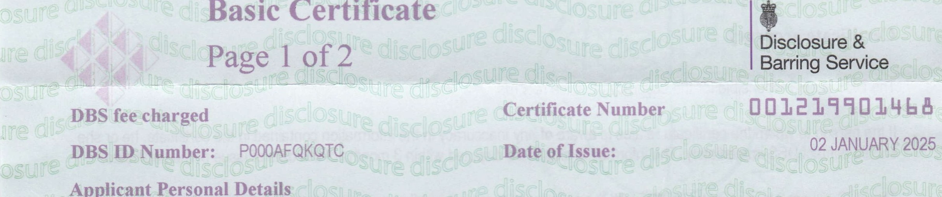

Basic

Certificate

Applicant

Personal

Details

|  |  |
| --- | --- |
| Surname: | ROTHAN |
| Forename(s): | DAVID JOHN |

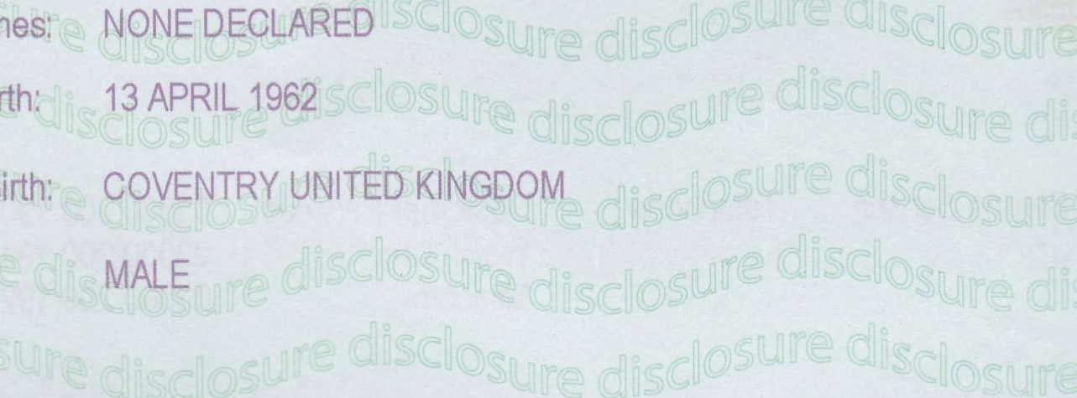Other Names: 

Date of Birth:

Place of Birth:

Gender: 

|  |
| --- |
| Police Records of Convictions, Cautions, Reprimands and Warnings  NONE RECORDED |

## Basic Certificate

This document is a basic certificate within the meaning of section 112 of the Police Act 1997,



## This section provides general information in the use and content of this certificate. For further detailed information see our website www.gov.uk/dbs